pleasantville ayso Blue sombrero guide : Coach Communication

Introduction
In Summer 2017 AYSO nationally adopted the blue sombrero product to act as a registration/team management/ admin portal. As of fall 2017 there are still a number of non-intuitive functions in that portal and a series of how to guides is being produced to help users navigate the noise.
This document focuses on team communication for Assistant and Head Coaches

basic Setup
In order to send emails form the system you need to be assigned as either an assistant or head coach on a Team.
The first step is to access your teams "Team Page"
These can be found here
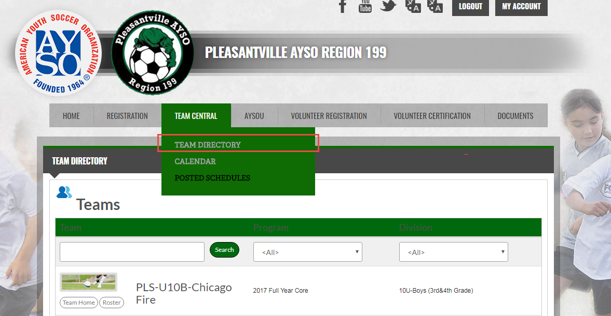
Find your Team and select Team Home

How to Make a Post
What you want to do is start a discussion :
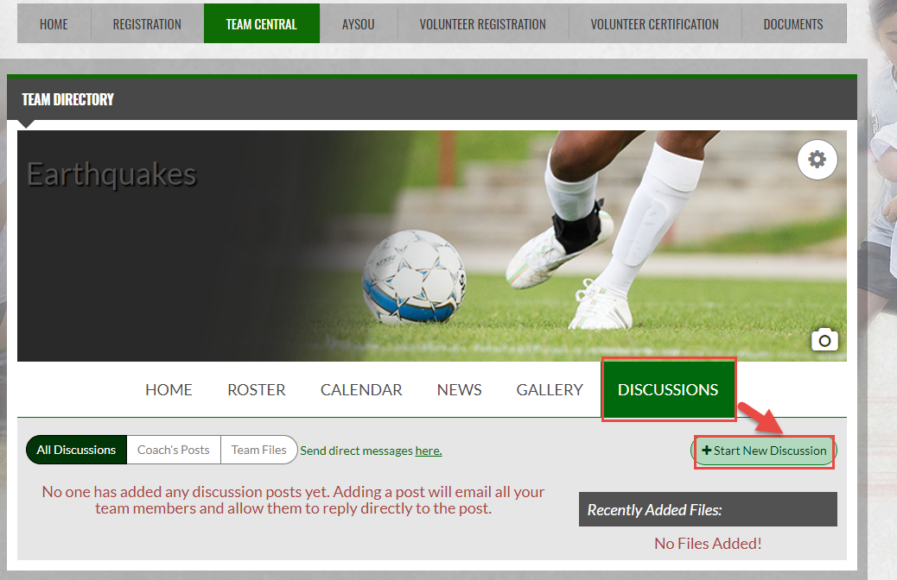

What Goes in a Discussion
This is just like writing an email, it requires a subject and some data
Make sure the subject is meaningful, you can also add file attachments to the discussion.
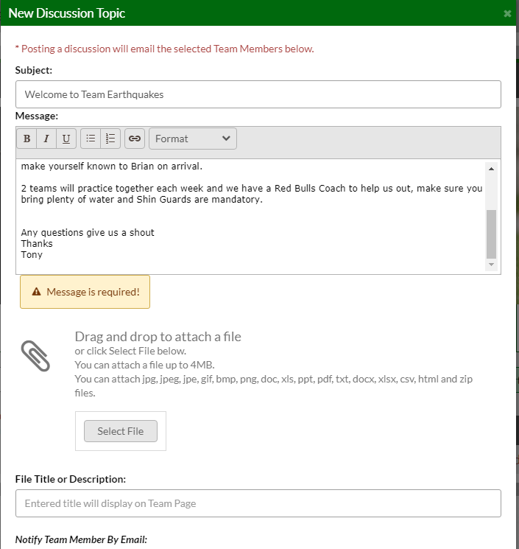
Once you're done hit OK .

Discusion board settings
You can enable or disable commenting on your board by clicking on the gear icon in the picture :
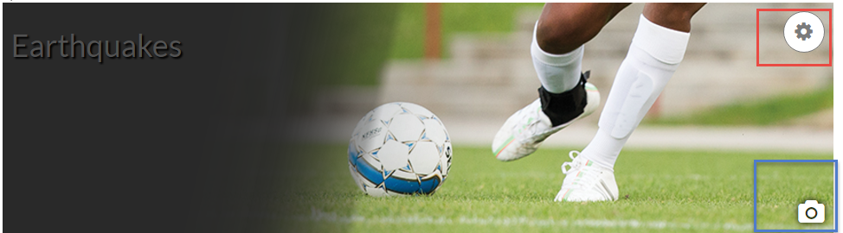
Then choosing to allow commenting
If you click on the camera icon you can change your teams logo – go-on hold a logo completion and change the picture .

Discussion board benefits
The discussion board changes the way we communicate with our parents, its more interactive and less email focused the benefits are :
Its right there on the team page !
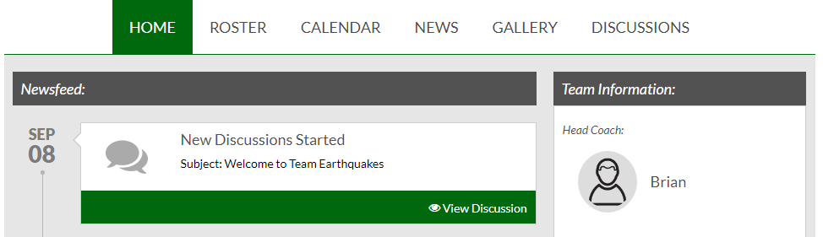
And its on the Discussions tab for future reference allowing you to point new team members, or peopple who said they didn’t get the mail somewhere to look.

App Benefits
The nice thing about the discussions is that they are also available on the Dicks Team Sports HQ app
http://www.bluesombrero.com/dicks-tshq-mobile-app/
You can see all your discussions for all your teams in one simple portal:
